In multicellular organisms, cell division is a normal process. Cells divide for growth, for the development of organs, for healing of wounds and also for the replacement of older and damaged cells. Cell division is a very complex process which is controlled by a regulatory mechanism at both molecular and cellular level.
Again, in higher multicellular organism, each and every cell belongs to a particular type of tissue like epithelial tissue, connective tissue muscular tissue etc.
Hence, when a cell of a specific tissue divides, it normally produces its own kinds of cell of the tissue to which it belongs. It never produces the cells of other tissues. Therefore, the process by which cells achieve this specification and specialisation is known as cellular differentiation. Differentiation of cell begins during embryonic gastrulation stage and continues through tissue formation.
Actually differentiation has a genetic basis and the process results from the interaction of the nucleus and the cytoplasm. After the cells become well- differentiated, they cannot go back normally to the undifferentiated stage unless disturbed internally or externally.
Therefore, in multicellular organism, the cell division, differentiation and survival of individual cells are carefully regulated to meet the needs of the organism as a whole. When this regulation is lost due to any reason, the cells behave unusually and defy their control mechanism.
Then the cells grow and divide in an uncontrolled manner ultimately spreading throughout the body and interfering with the functions of normal tissues and organs. As a whole, this condition leads to cancer. Cancer develops from defects in fundamental regulatory mechanisms of the cell.

Cancer:
Cancer is a non-infectious disease. It starts at the molecular level of the cell and, ultimately affects the cellular behaviour. Generally, it can be defined as uncontrolled proliferation of cells without any differentiation.

Types of Cancer:
Cancer is a large class of diverse disease. All types of cancer can result from uncontrolled cell growth and division of any of the different kinds of cells in the body. So there are more than a hundred distinct types of cancer which vary in their behaviour and response to treatment.
The uncontrolled cell growth produces a mass of cells which are called tumours or neoplasm tumours may be benign or malignant. A benign tumor remains confined to its original location. They do not invade the surrounding normal tissues. They do not spread to distant body sites.
The most common example of tumour is the skin wart. A benign tumour consists of closely resembles normal cells and may function like normal cells. Generally benign tumours are harmless and can usually be removed surgically. However, these tumours may sometimes become quite harmful if they are located in organs like brain and liver.
A malignant tumour does not remain confined to its original location. They are capable of both invading surrounding normal tissue and spreading throughout the body via the circulatory or lymphatic systems. Malignant tumours become life-threatening if, they spread throughout the body.
Only malignant tumours are properly designated as cancers. The cells of malignant tumour are derived from single cell, thus they are monoclonal in character. Malignant tumour is composed of aberrant cells. They behave like embryonic type, undifferentiated, having irregular, large nucleus, and deficient of cytoplasm. Malignant tumours are generally classified into four main types on the basis of cell type from which they arise.

(i) Carcinomas:
It includes approximately 90% of human cancer. This type is principally derived from epithelial cells of ectoderm and endoderm. The solid tumours in nerve tissue and in tissues of body surfaces or their attached glands are example of carcinomas. Cervical, breast, skin and brain carcinomas are developed from malignant tumour.

(ii) Sarcomas:
Sarcomas are solid tumours of connective tissues such as muscle, bone, cartilage and fibrous tissue. This type of malignant tumours are rare in human (about 2% of human cancer).

(iii) Lymphomas:
It is a type of malignancy in which there is excessive production of lymphocytes by the lymph nodes and spleen. It accounts for approximately 8% of human cancers. Hodgkin’s disease is an example of human lymphoma.

(iv) Leukemia’s:
This type of malignancy arises from the blood forming cell. Leukemia’s are commonly known as blood cancer. Leukemia’s are neoplastic growth (uncontrolled cell growth at the cost of remaining cells) of leucocytes or WBC.
They are characterised by excessive production of WBC of the blood. The name leukemia is derived from Greek leukos (white) + haima (blood) the massive proliferation of leukemia cells can cause a patient’s blood to appear milky.
In addition to the types of cancer mentioned above, cancers are further classified according to tissue of origin, for example lung cancer, breast cancer, and the type of cells involved, for example fibro sarcoma arises from fibroblasts, erythromoid leukemia’s from precursor of erythrocytes. Although there are many kinds of cancer, the four most common cancers are those of prostrate, breast, lung and colon/rectum.

Development of Cancer:
The development of cancer is a multistep process in which cells gradually become malignant through a progressive series of alternations. This process involves mutation and selection for cells with progressively increasing capacity for cell division, survival, invasion and metastasis (spread of cancer cells through the blood or lymphatic system to other organ sites).
The first step in the process is when a single cell within a tissue of the organ concerned is genetically modified. The modified cell divides rapidly, although surrounding cells do not— and a mass of tumour cells forms.
These cells constitute a clone where cells are identical in terms of structure, characteristics and function. Rapid cell proliferation leads to the tumorous outgrowth or adenoma or polyp. This tumour is still benign.
Tumour progression continues as additional mutation occur within cells of tumour population. Some of these mutations give a selective advantage to the cell such as rapid growth and the descendants of a cell bearing such a mutation will consequently become dominant within the tumour population.
This process is known as clonal selection. Clonal selection continues throughout tumour development and, consequently, tumour become more and more rapid, growing and increasingly malignant. The tumour cells, by their rapid proliferation, invades the basal lamina that surrounds the tissue.
Then tumour cells spread into blood vessels that will distribute them to other sites in the body. This is known as metastasis. If the tumour cells can exit from the blood vessels and grow at distant site, they are considered malignant
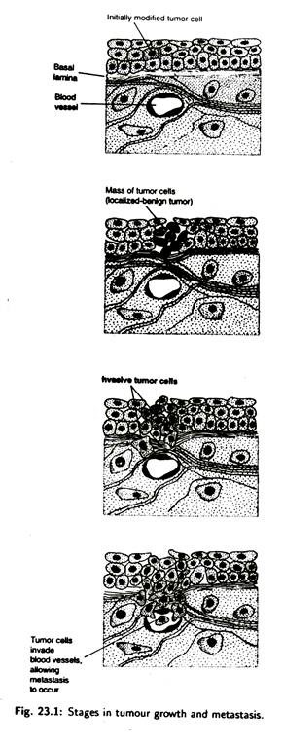
Cancer cells also secrete growth factors that promote the formation of new blood vessels. This is known as angiogenesis. Angiogenesis is necessary to support the growth of tumour beyond the size of about a million cells at which point new blood vessels are needed to supply oxygen and nutrients to the multiplying tumour cells.
Actually the growth factor secreted by the tumour cells stimulates the endothelial cells present in the wall of capillaries.
As a result, new outgrowth of the capillaries is formed into the tumour. These outgrowths of capillaries are also helpful for metastasis of malignant cells. Therefore, angiogenic stimulation induces the growth of new blood capillaries which penetrate easily in the tumour tissue and provide the opportunity for the cancer cells to enter the circulatory system. As a result, metastasis process begins.

(vii) Apoptosis:
For every cell, there is a fixed span of life, i.e., time to live and time to die. This cell death is a very orderly process and so it is called Programmed Cell Death or PCD or Apoptosis. Apoptosis is a mechanism of programmed cell death or cell suicide which is essential for the survival of the organism, for the normal development of the organism as the programmed destruction of the organism as the programmed destruction of cells is found during embryo-genesis. It also protects the organism by removing damaged cells which may be due to viral infection or due to exposure to radiations. It also inhibits the tumour development and so any defect in the control of apoptosis may lead to cancer.
There are two methods by which cells may die such as:
1. Death by injury that is through mechanical damage or due to toxic chemicals.
2. By Apoptosis, i.e., through programmed cell death.
(a) Characteristic changes during apoptosis:
The following distinct morphological changes are found during apoptosis:
1. Shrinkage of cells.
2. Cell forms tight sphere.
3. Cell membrane forms bubble-like blebs on the outer surface.
4. Occurrence of nuclear membrane break.
5. Endonucleolytic clearance of DNA at inter-nucleosomal sites occurs leading to the degradation of chromatin.
6. Breakdown of mitochondria is found with the release of cytochrome C.
7. Breakage of cells into small fragments.
8. Engulfment of cells fragments by phagocytic cells:
(b) Genetic Control of Apoptosis:
Some apoptosis genes have already been identified which are responsible for switching on or off apoptosis. These genes include ICE (Interleukin-lb-Converting Enzyme) and P53. There are other factors that also regulate the process of apoptosis.
One of them is the signal protein which is released either due to some cell injury or through cytokine medicated pathways. There are some critical proteins or modulating factors which determine whether a cell will be repaired or undergo death.
These genes or factors may initiate some stimuli for cell death or induces cellular susceptibility to apoptosis or initiates some effector mechanisms for apoptosis. Some of the genes or factors responsible for apoptosis are listed in the Table 23.1.

(c) Mechanism of Apoptosis:
There are generally three different mechanisms for apoptosis. These are:
1. Triggered by internal signals, i.e., signals arising within the cell.
2. Triggered by external signals.
3. By Apoptosis-Inducing Factor (AIF).
1. By Internal Signals:
In a normal cell, the protein (BC1-2) produced from a gene BC1-2 remains on the outer surface of the mitochondria. The protein BC1-2 holds the apoptotic protease activating factor- 1 (Apaf-1). But when the damage occurs in the cell internally due to some reactive oxygen, the Apaf-1 factor is released from BC1- 2-Apaf-l complex.
This allows the protein Bax to penetrate the mitochondrial membrane causing a leakage of cytochrome C from the mitochondria.
Then the released cytochrome C and Apaf-1 bind to molecules of caspase 9. The complex containing cytochrome C, Apaf- 1, caspase 9 and ATP is called Apoptosome. Caspase 9 is actually one form of protease which cleaves proteins at Aspartic acid residues.
The caspase 9 activates other caspases creating a cascade of proteolytic activity which leads to the lysis of cell through digestion of structural proteins of the cytoplasm and degradation of chromosomal DNA.
2. External Signals:
Some receptor proteins (FAS and TNF) and other molecules residing on the surface of the cell are responsible for apoptosis. when cyto- tosic T cells containing complementary factor FASL bind to the target cell, FASL binds with the FAS of the target cell leading to the death of the cell by apoptosis.
3. Apoptosis-Inducing Factor (AIF):
This AIF is a protein located in the inter-membrane space of mitochondria. When the cell receives the signal for its death, AIF is released from the mitochondria to the cytoplasm. AIF then goes to the nucleus and binds to DNA causing destruction of the DNA and finally the death of the cell.
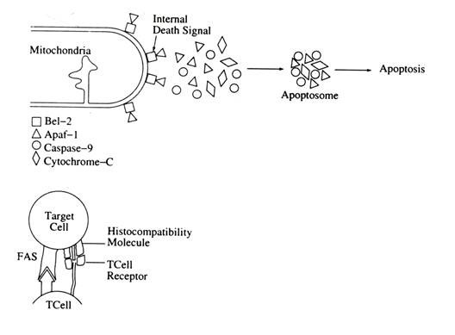
In case of cancer, there are some virsus like Human Papilloma Virus (HPV), Epstein-Barr Virus (EBV) produce a special type of protein E6 or BC1-2 which inactivately apoptosis promoter P 53, leading to the proliferation of cancer.
Again those cancer cells without the intervention of viruses also have some techniques to inactivate apoptosis. some B-cell leukemia’s Melanoma (one type of skin cancer), lung cancer cells, colon cancer cells, etc. produce some proteins or factors like BC1-2 “decoy” molecule, Fas L can avoid apoptosis by inhibiting Apaf-1, or binding to Fas leading to proliferation of cancer.

Notes # 6. Causes of Cancer:
What causes cancer?
- biological or internal factors, such as age, gender, inherited genetic defects and skin type.
- environmental exposure, for instance to radon and UV radiation, and fine particulate matter.
- occupational risk factors, including carcinogens such as many chemicals, radioactive materials and asbestos.
- lifestyle-related factors.

Causes
Cancer is caused by changes (mutations) to the DNA within cells. The DNA inside a cell is packaged into a large number of individual genes, each of which contains a set of instructions telling the cell what functions to perform, as well as how to grow and divide. Errors in the instructions can cause the cell to stop its normal function and may allow a cell to become cancerous.

What do gene mutations do?
A gene mutation can instruct a healthy cell to:
- Allow rapid growth. A gene mutation can tell a cell to grow and divide more rapidly. This creates many new cells that all have that same mutation.
- Fail to stop uncontrolled cell growth. Normal cells know when to stop growing so that you have just the right number of each type of cell. Cancer cells lose the controls (tumor suppressor genes) that tell them when to stop growing. A mutation in a tumor suppressor gene allows cancer cells to continue growing and accumulating.
- Make mistakes when repairing DNA errors. DNA repair genes look for errors in a cell's DNA and make corrections. A mutation in a DNA repair gene may mean that other errors aren't corrected, leading cells to become cancerous.
These mutations are the most common ones found in cancer. But many other gene mutations can contribute to causing cancer.

What causes gene mutations?
Gene mutations can occur for several reasons, for instance:
- Gene mutations you're born with. You may be born with a genetic mutation that you inherited from your parents. This type of mutation accounts for a small percentage of cancers.
- Gene mutations that occur after birth. Most gene mutations occur after you're born and aren't inherited. A number of forces can cause gene mutations, such as smoking, radiation, viruses, cancer-causing chemicals (carcinogens), obesity, hormones, chronic inflammation and a lack of exercise.
Gene mutations occur frequently during normal cell growth. However, cells contain a mechanism that recognizes when a mistake occurs and repairs the mistake. Occasionally, a mistake is missed. This could cause a cell to become cancerous.

How do gene mutations interact with each other?
The gene mutations you're born with and those that you acquire throughout your life work together to cause cancer.
For instance, if you've inherited a genetic mutation that predisposes you to cancer, that doesn't mean you're certain to get cancer. Instead, you may need one or more other gene mutations to cause cancer. Your inherited gene mutation could make you more likely than other people to develop cancer when exposed to a certain cancer-causing substance.
It's not clear just how many mutations must accumulate for cancer to form. It's likely that this varies among cancer types.

Risk factors
While doctors have an idea of what may increase your risk of cancer, the majority of cancers occur in people who don't have any known risk factors. Factors known to increase your risk of cancer include:

Your age
Cancer can take decades to develop. That's why most people diagnosed with cancer are 65 or older. While it's more common in older adults, cancer isn't exclusively an adult disease — cancer can be diagnosed at any age.

Your habits
Certain lifestyle choices are known to increase your risk of cancer. Smoking, drinking more than one alcoholic drink a day (for women of all ages and men older than age 65) or two drinks a day (for men age 65 and younger), excessive exposure to the sun or frequent blistering sunburns, being obese, and having unsafe sex can contribute to cancer.
You can change these habits to lower your risk of cancer — though some habits are easier to change than others.

Your family history
Only a small portion of cancers are due to an inherited condition. If cancer is common in your family, it's possible that mutations are being passed from one generation to the next. You might be a candidate for genetic testing to see whether you have inherited mutations that might increase your risk of certain cancers. Keep in mind that having an inherited genetic mutation doesn't necessarily mean you'll get cancer.

Your health conditions
Some chronic health conditions, such as ulcerative colitis, can markedly increase your risk of developing certain cancers. Talk to your doctor about your risk.

Your environment
The environment around you may contain harmful chemicals that can increase your risk of cancer. Even if you don't smoke, you might inhale secondhand smoke if you go where people are smoking or if you live with someone who smokes. Chemicals in your home or workplace, such as asbestos and benzene, also are associated with an increased risk of cancer.

Many agents including radiation, chemicals and viruses have been found to induce cancer in both experimental animals and humans. Agents which cause cancers are called carcinogens. Radiation (Solar ultraviolet ray, X-ray) and chemical carcinogens act by damaging DNA and inducing somatic mutations.
These carcinogens are generally called initiating agent because the induction of mutations in key target genes is supposed to be the initial event leading to cancer development.
Some of the initiating agents that cause human cancers include solar ultraviolet radiation—the major cause of skin cancer. The exposure of the thyroid gland to X-rays greatly increases the incidence of thyroid cancers.
Varieties of chemical carcinogen including tobacco smoke (containing benzo(a)pyrene, dimethyl nitrosamine and nickel compound) and aflatoxin produced by some molds are the major identified cause of human cancer. Other carcinogens induce the cancer development by stimulating cell proliferation rather than inducing mutations. Such compounds are called tumour promoters.
The first suggestion that chemicals can cause cancer dates back to 1761, when a doctor noted that people who use snuff suffer from nasal cancer. A few years later a British physician observed a high incidence of cancer of the scrotum among the chimney-sweepers iii their youth.
He explained the fact that the chimney soot became dissolved in the natural oil of the scrotum, irritating the skin and, consequently, initiates the development of cancer. On the basis of two separate observations it became evident that certain chemicals (Table 23.1) can cause cancer.
Later, as the industrial revolution moved into twentieth century, more and more incidence of cancer were reported among the workers who were continuously exposed to industrial chemicals.

In the early 1940s Peyton Rous observed that repeated application of coal tar to rabbit skin causes tumour to develop, but the tumour disappears when application of the coal tar is stopped. It is also noted that when the skin is treated with turpentine, tumour again reappears.
Normally turpentine does not cause cancer itself. Therefore the coal tar and turpentine are playing two different roles. Some carcinogens induce some normal cells to become irreversibly altered to a pre-neoplastic state.
This is known as initiation and the carcinogens are known as initiation agents. Here coal tar is an initiating agent. On the other hand, some carcinogens stimulate the pre-neoplastic cells to divide and form tumour. This is known as promotion and the carcinogens are termed promoting agents. Here turpentine behaves as promoting agents.
Berenblum observed that painting the skin of a mouse a single time with methylcholanthrene rarely causes the development of tumours. But subsequently application of castor oil (an oil derived from seeds of Croton tiglium) triggers the formation of multiple tumours on the skin which has been exposed previously to methylcholanthren is acting as an initiator whereas castor oil acts as a promoter.
Initiation is a quick, irreversible process that causes a permanent change in a cell’s DNA. The carcinogenic chemicals that act as initiating agent are capable to bind with DNA. Hence they interfere with the normal function of DNA and induce somatic mutation and, consequently, bring about stable, inheritable changes in the cell’s properties.
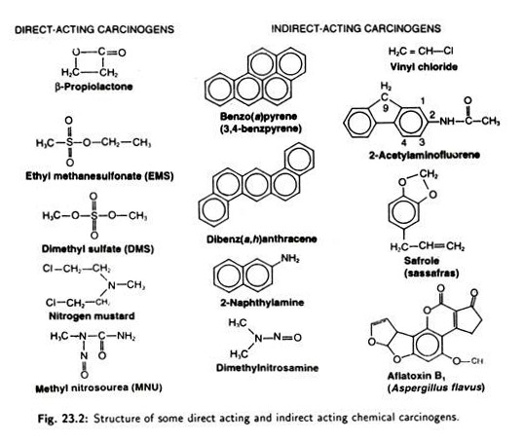
On the basis of action of chemical carcinogens on DNA, there are two broad categories of carcinogens—direct acting and indirect acting (Fig. 23.2). Direct acting carcinogens are highly electrophilic compounds that react with DNA.
Indirect acting carcinogens are converted to ultimate carcinogens by introduction of electrophilic centres. In other words, indirect acting carcinogens must be metabolised before they can react with DNA.

On the other hand, promotion is a gradual, partially reversible process that needs prolonged exposure to promoting agents. If a cell that has already undergone initiation is exposed to a promoting agent, the cell starts to divide and the number of genetically damaged cells goes up.
As the damaged cells continue to divide, a gradual selection for cells showing higher growth rate and invasive properties occurs—leading to the formation of malignant tumour. The promotion phase continues for longer period. That is why cancer does not develop just after exposure to a carcinogenic agent.
The mechanism of action of promoting agents have come from the studies of phorbol esters which are present in castor oil and act as tumour promoters. Phorbol esters bind to the plasma membrane and activate protein kinase C. Protein kinase C is a component of the phosphoinositide signalling pathway whose activity is normally controlled by the second messenger, diacylglycerol.
The activation of protein kinase C leads to phosphorylation of many target proteins and, consequently, activates the transcription factor API which switches on the transcription of genes involved in stimulating cell proliferation. Therefore, the mode of action of phorbol esters gives an insight into the possible mechanism of action of a promoting agent.
Energy that travel through space is known as radiation. Natural source of radiation to which humans are generally exposed are ultraviolet rays, cosmic rays and emission from radioactive elements. We are also exposed to another high- energy radiation like X-ray. Medical, industrial and military activities generally create the high-energy radiation.
Sunlight has the ability to cause skin cancer in people who spend long hours in the sunlight. Sunlight contains ultraviolet rays which are also absorbed by normal skin pigmentation. Hence, for this reason, dark-stained or black people usually have lower rates of skin cancer than fair- skinned individual.
Because ultraviolet radiation is very weak to pass through the skin, it does not induce any other type of cancer except skin cancer. It is more or less restricted superficially on skin because skin cancer rarely metastasizes.
This type of cancer can be cured by easily removing the affected site surgically. Xeroderma pigmentosum is a type of inherited malignant disease. Individuals with this malignant disease develop extensive skin tumours after exposure to sunlight. Homozygotes for the autosomal recessive mutation responsible for xeroderma pigmentosum are less efficient in the repair of DNA damaged by exposure to ultraviolet light.
X-rays are high energy radiation. They are strong enough to penetrate the skin and reach internal organs. X-rays thus make a serious cancer hazard because they are able to induce gene mutation or DNA damage. Many radioactive elements emit radiation. It also acts as carcinogen and causes cancer.
Marie Curie, the co-discoverer of the radioactive elements polonium and radium, died of a form of leukemia that appeared to be caused by her extensive exposure to radioactivity. Another example of radiation-induced cancer occurred in New Jersey in 1920. A group of women was employed by a factory that produced watch which glow in the dark. The luminescent point used to point the watch dial contained radium.
The paint was applied with a fine-tipped brush that the employee frequently wetted with their tongue. During this process, minute quantities of radium were ingested through saliva in the digestive system from where they were readily abs, -bed and distributed in the different cells ana tissues thorough circulatory system.
Several years later these women suffered from bone cancer caused by radioactive radium that had gradually become concentrated in their bone.
The most well-known horrifying examples of radiation-induced cancer occurred in Japan and in Nevada of United States. In 1945 atomic bombs were exploded over Hiroshima and Nagasaki. The massive fallout of radioactive elements increased the incidence of leukemia, lymphomas and cancers of the thyroid, breast,’ uterus and gastrointestinal tract.
Similarly, in Nevada, people suffered from cancer due to the radioactive fallout during nuclear bomb testing. It is suggested that radioactive carcinogen is thought to initiate malignant transformation by causing DNA damage. Alternatively, it is also explained that subsequent exposure of radiation damaged cells to promoting agents stimulates the cell to divide abnormally and form tumour.
There are many viruses which are capable of causing tumour in animals, humatf as well as plants (Table 23.2). These viruses are called tumour viruses or oncovirus. Some tumour viruses have RNA genome and are known as DNA tumour viruses.
Some tumour viruses have DNA genome and are known as retroviruses. Retrovirus replicates via synthesis of a DNA provirus in the infected cells. In addition, HIV is indirectly responsible for the cancer that develops in AIDS patient as a result of immunodeficiency.
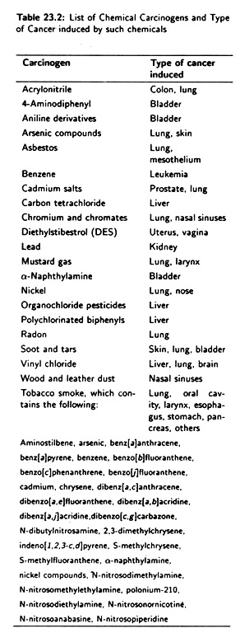
The herpes viruses are the most complex animal viruses. The genome length of these viruses is 100-200 Kb. Many herpes viruses cause tumour in many animals such as frogs, chickens, monkeys etc. Epstein-Barr virus, a member of herpes virus, can trigger the development of some human malignancies including Burkett’s lymphoma in some region of Africa and nasopharyngeal carcinoma in China.
It also causes B-cell lymphomas in AIDS patient and other immunosuppressed persons. Cell transformation by herpes viruses is not fully understood because of the complexity of their genome. But it is evident that some viral genes are required to induce transformation of lymphocytes.
Of the DNA tumour viruses, the papoviruses are the best studied DNA tumour viruses from the standpoint of molecular biology and have received particular attention because they have been critically important as models for understanding the molecular basis of cell transformation.
The genome size of papoviruses is small (approximately 5 Kb). Simian virus 40 (SV₄₀) and polyomavirus are the important and commonly known member of papoviruses. Both these viruses are similar in size and general structure.
A virus usually multiplies in specific cells derived from animals in which the virus normally grows. Such cells are called permissive cells. Cells which do not allow the viruses to grow are called non-permissive cells.
SV₄₀ and polyoma viruses, on entering their respective host cells, undergo one of the two types of behaviour—they enter the permissive cell of the host, undergo the lytic phase, and multiply within host cell, ultimately killing them.
Since a permissive cell is killed as a consequence of virus replication, it cannot become transformed. Sometimes viruses enter non-permissive cells and are not able to multiply, i.e., virus replication is blocked. In this case, the viral genome sometimes integrates into cellular DNA and expression of specific viral genes results in transformation of the infected cells.
The SV₄₀ and polyoma virus genes that trigger cell transformation have been identified, isolated and sequenced by molecular analysis. The genome of SV₄₀ and polyomavirus are divided into early and late regions. The early region is expressed immediately after infection and is needed for synthesis of viral DNA.
The late region is not expressed until after viral DNA replication has begun.
Possibly tumour results from expression of a viral gene. Alternatively, the chronic cell damage of liver simply induce the continuous cell division which, ultimately, causes the cell transformation.
The retroviruses, one family of RNA viruses, also cause human cancer. For example, human T-cell lymphotropic virus type-I (HTLV- I), a RNA virus, is the causative agent of T-cell leukemia. A related virus (HTLV-II) cause a rare form of leukemia called hairy T- cell leukemia.
HIV (Human immunodeficiency virus) is the causative agent of AIDS. These viruses, i.e., HTLV-I, HTLV-II, HIV, actually does not cause cancer by directly converting a normal cell into a tumour cell. The AIDS patients become susceptible to high incidence of some malignancies like lymphomas and Kaposi’s sarcoma due to immunosuppression of the patient.

